**Project Implementation Phase**

|  |  |
| --- | --- |
| **Date** | **28-06-2025** |
| **Team ID** | **LTVIP2025TMID30072** |
| **Project Name** | **Jewel Management** |
| **Maximum Marks** |  |

**Custom Objects Creation:** Jewel customers, Items, Customer orders, Prices, Billings and I created two custom objects of my Choice (Design Requests, Repair Requests)

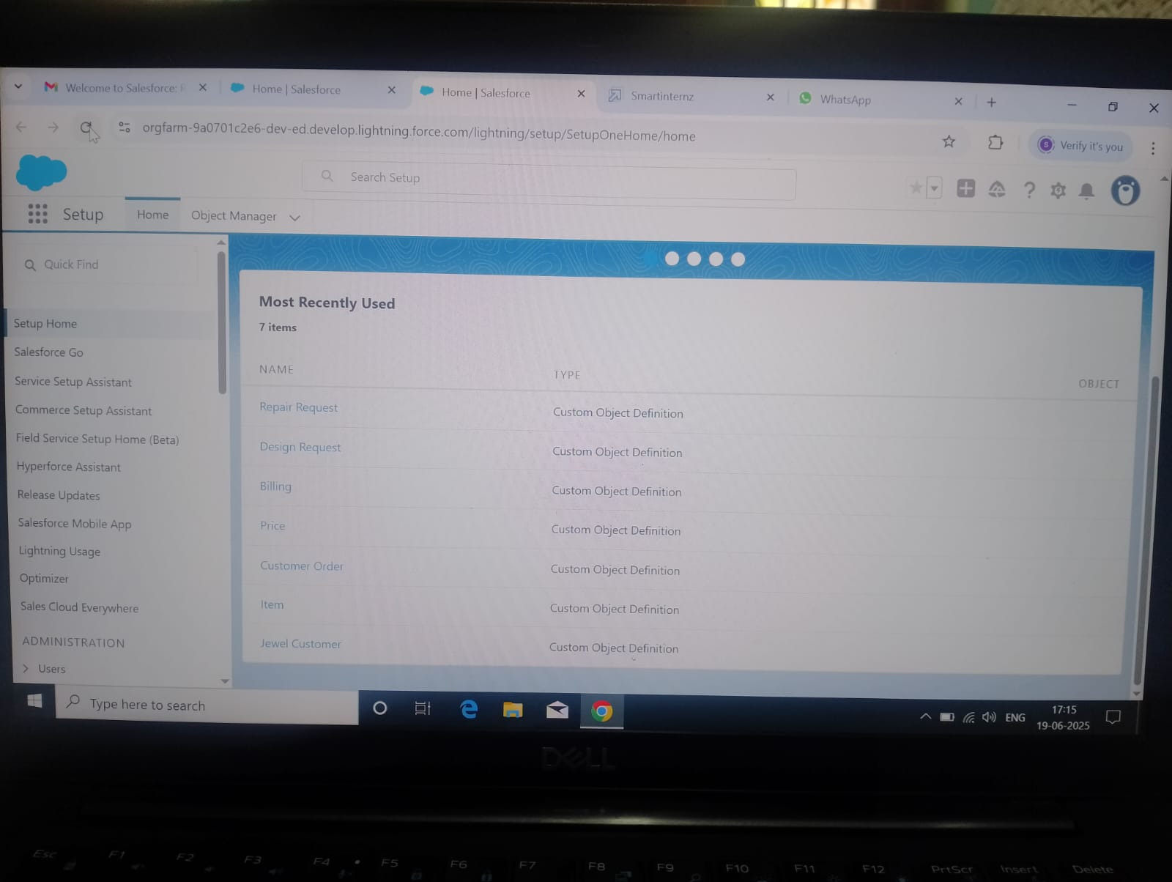

**Custom Tabs Creation:** Jewel customers, Items, Customer orders, Prices, Billings and Design Requests, Repair Requests.

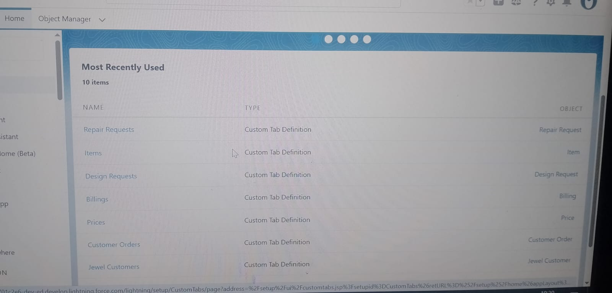 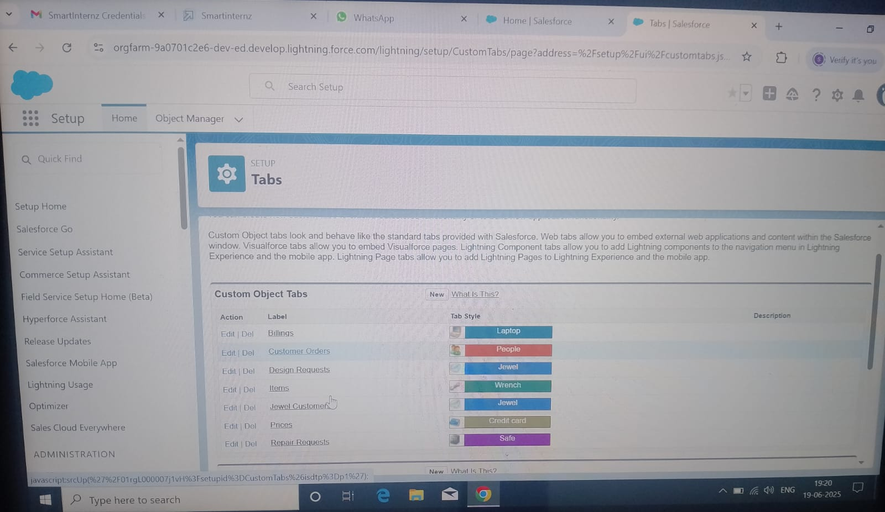

**Creation of Lightning App:**

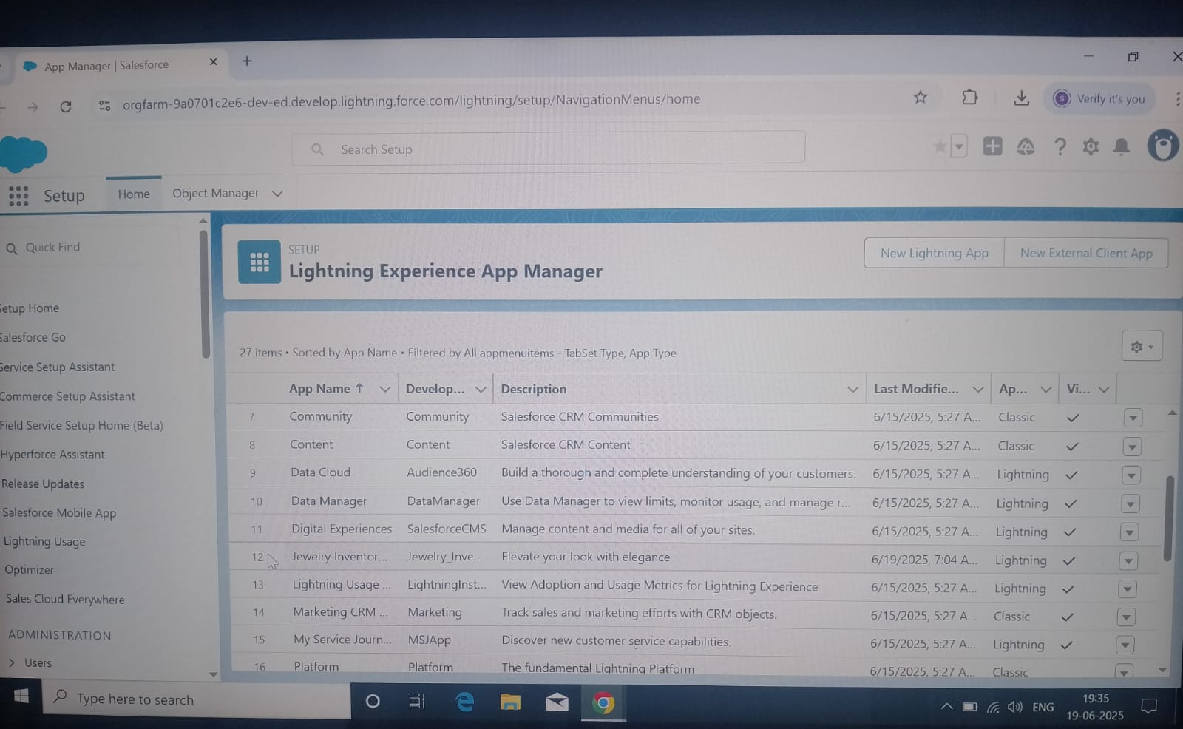

**Creation of Fields in Jewel Customers Object:**

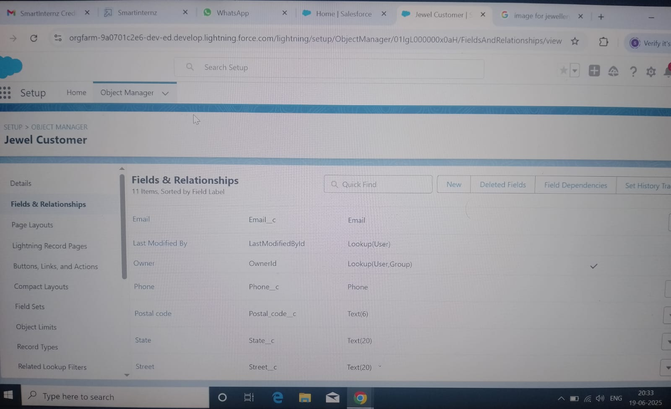

**Creation of Fields in Items Object:**

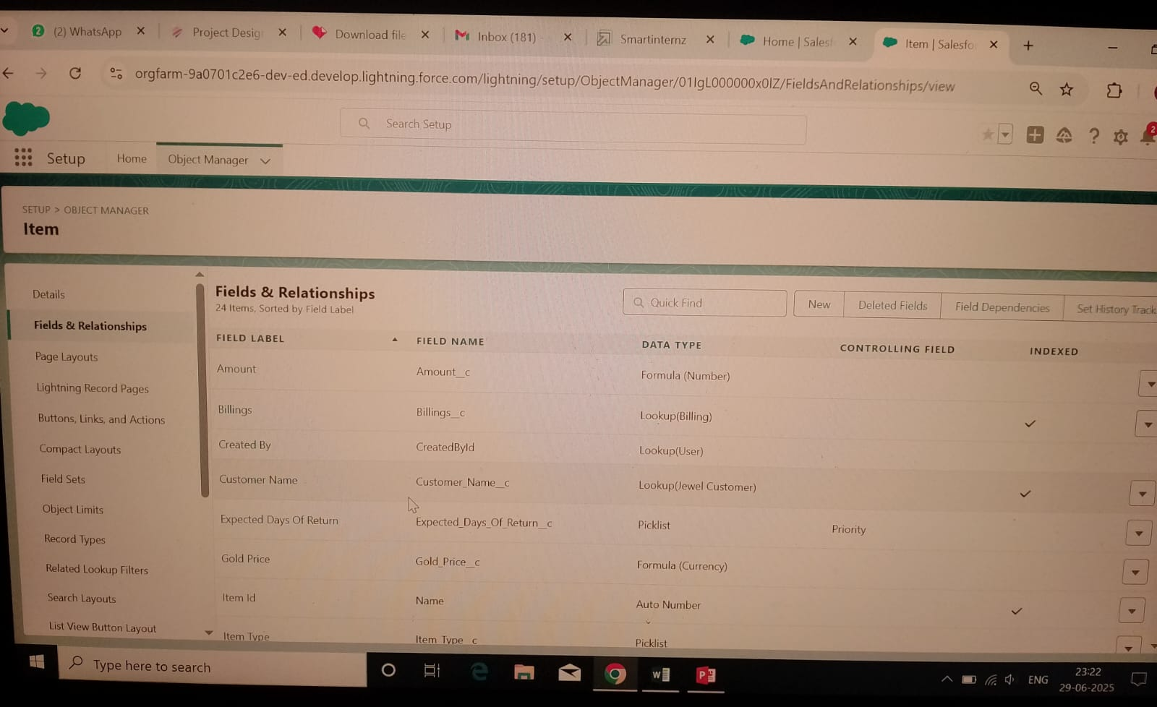

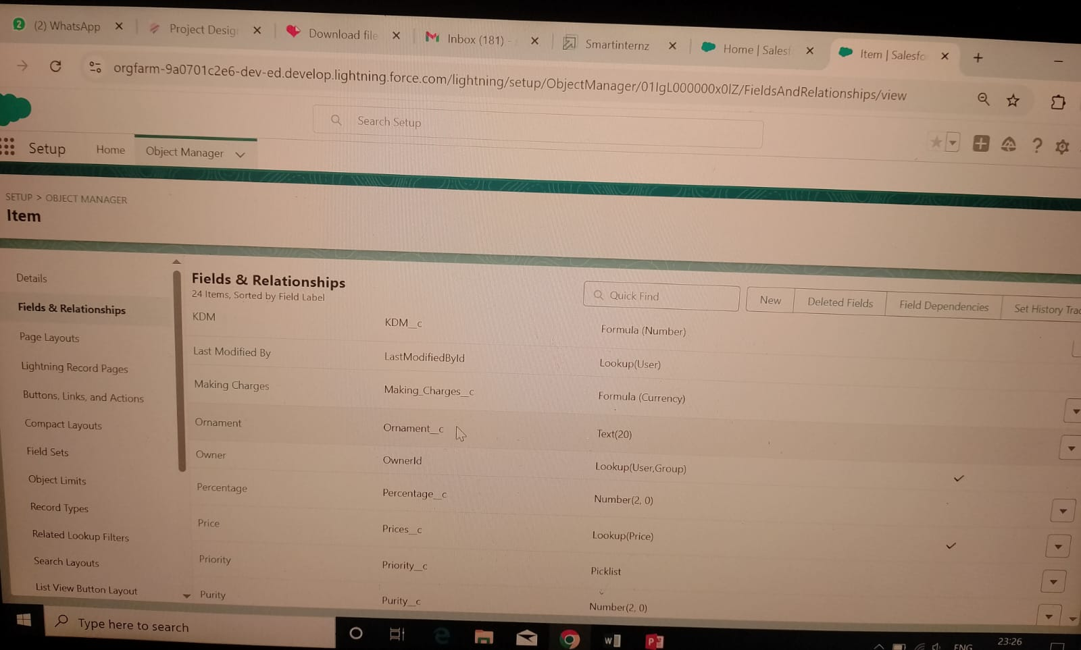

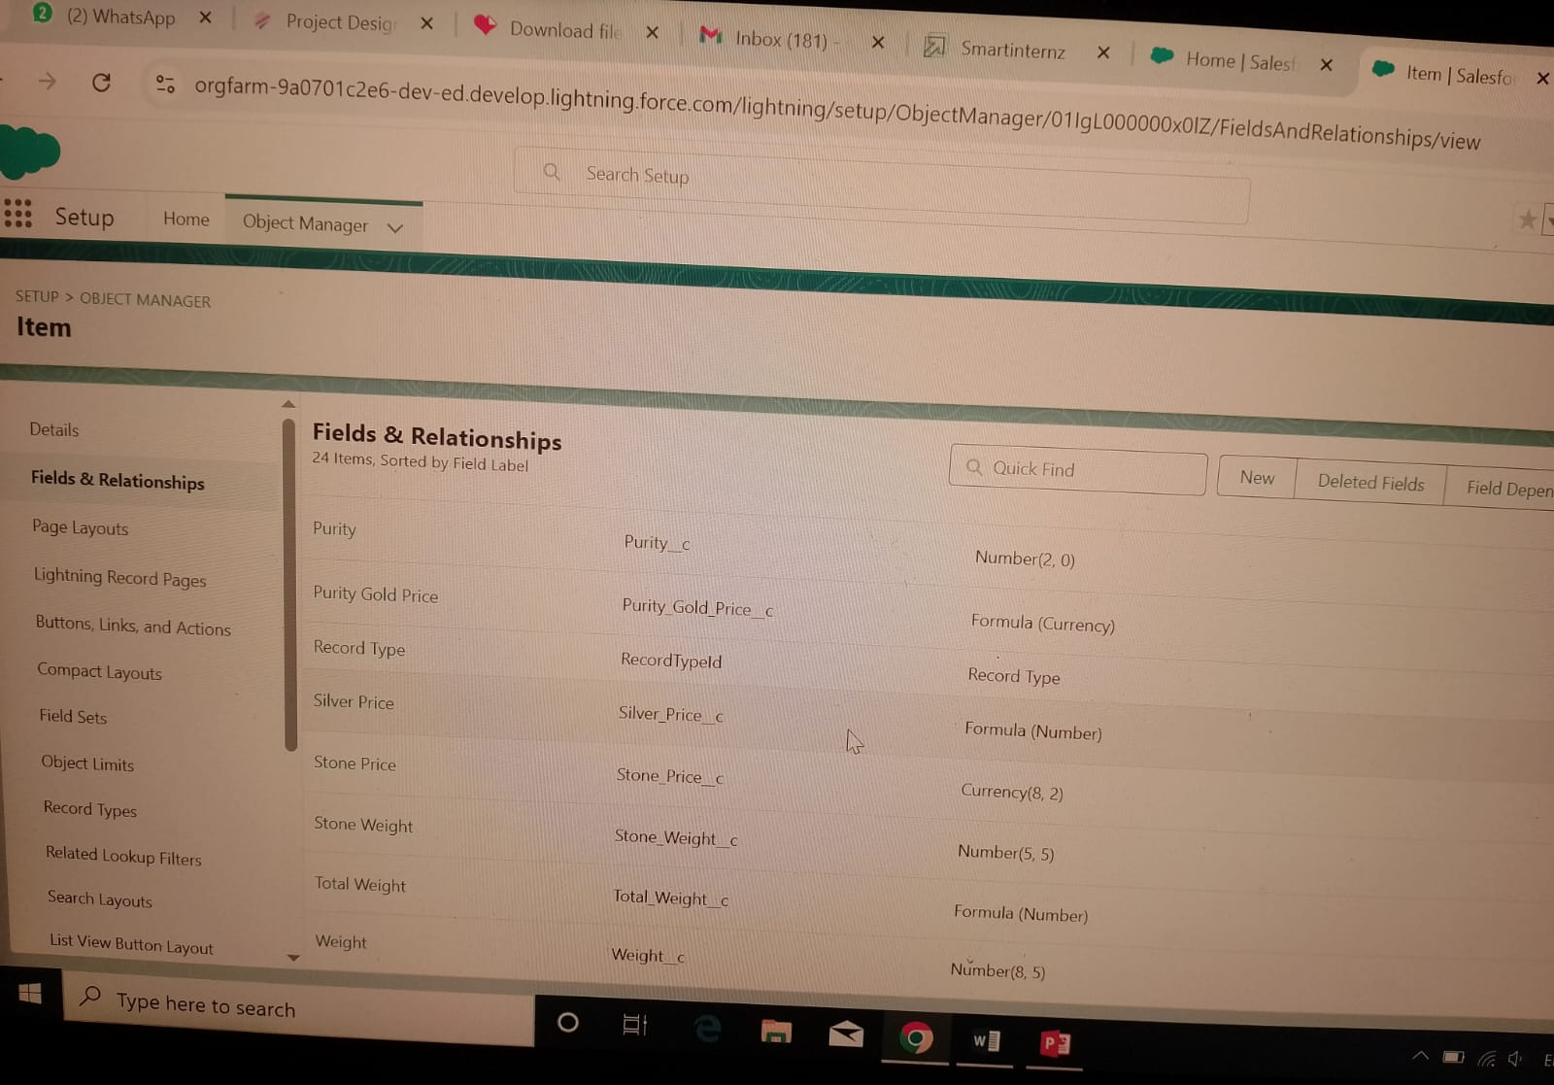

**Creation of Fields in Prices Object:**

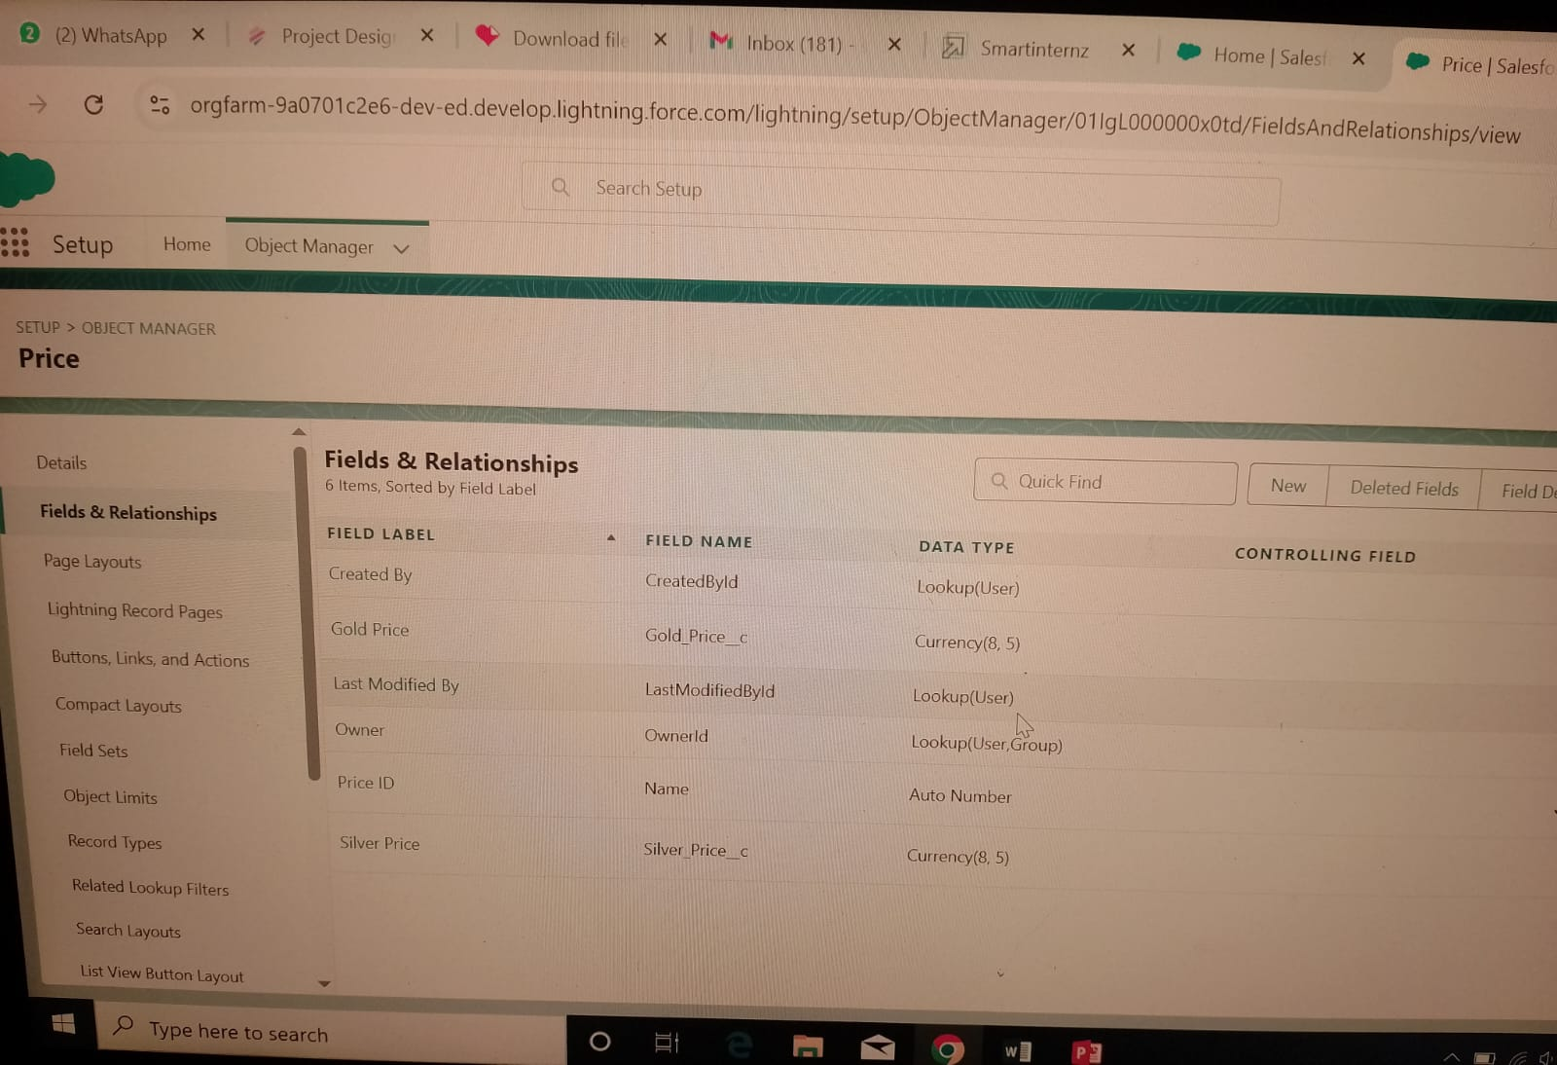

**Creation of Fields in Billings Object:**

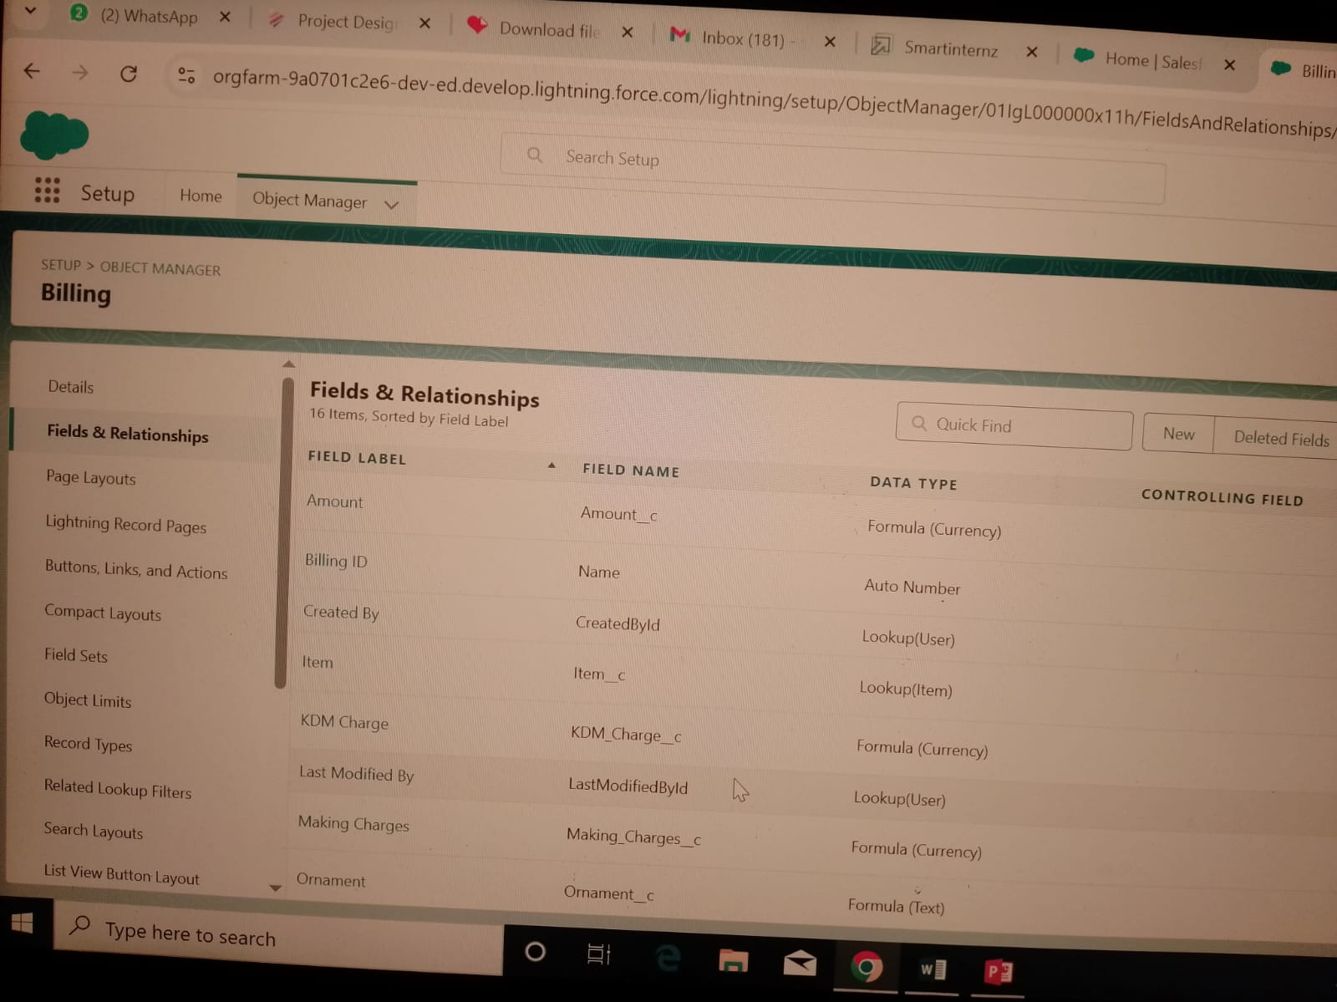

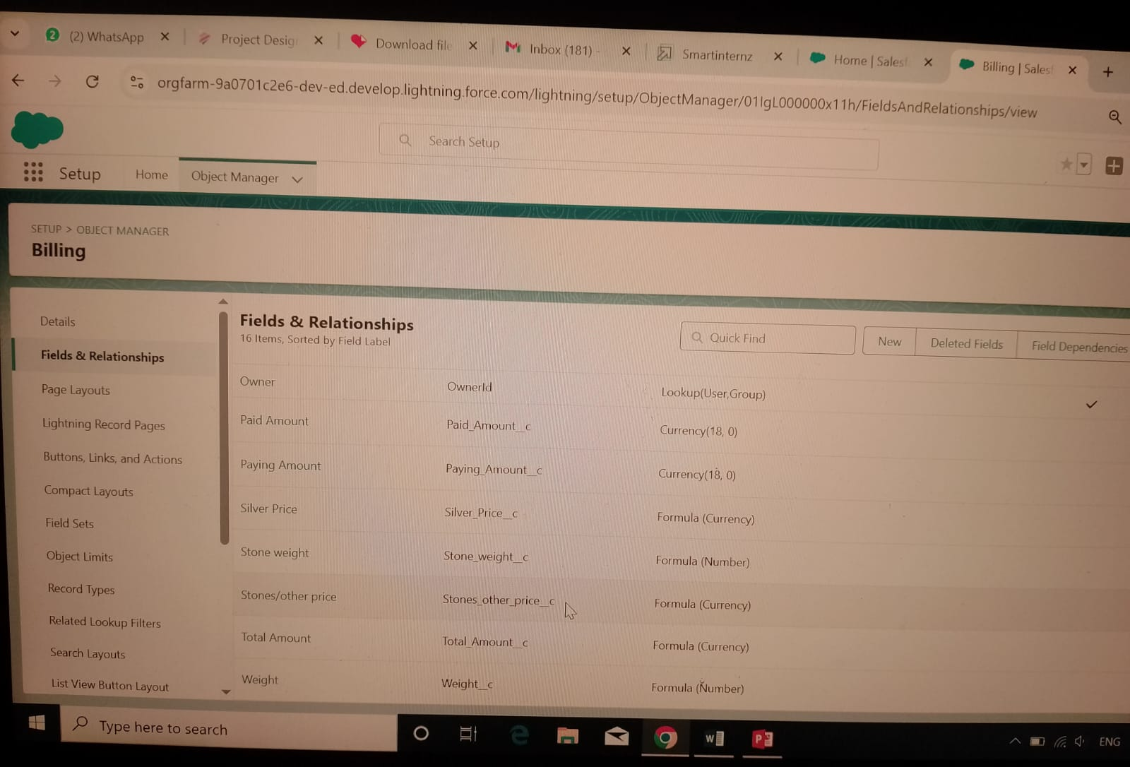

**Creation of Fields in Customer Orders Object:**

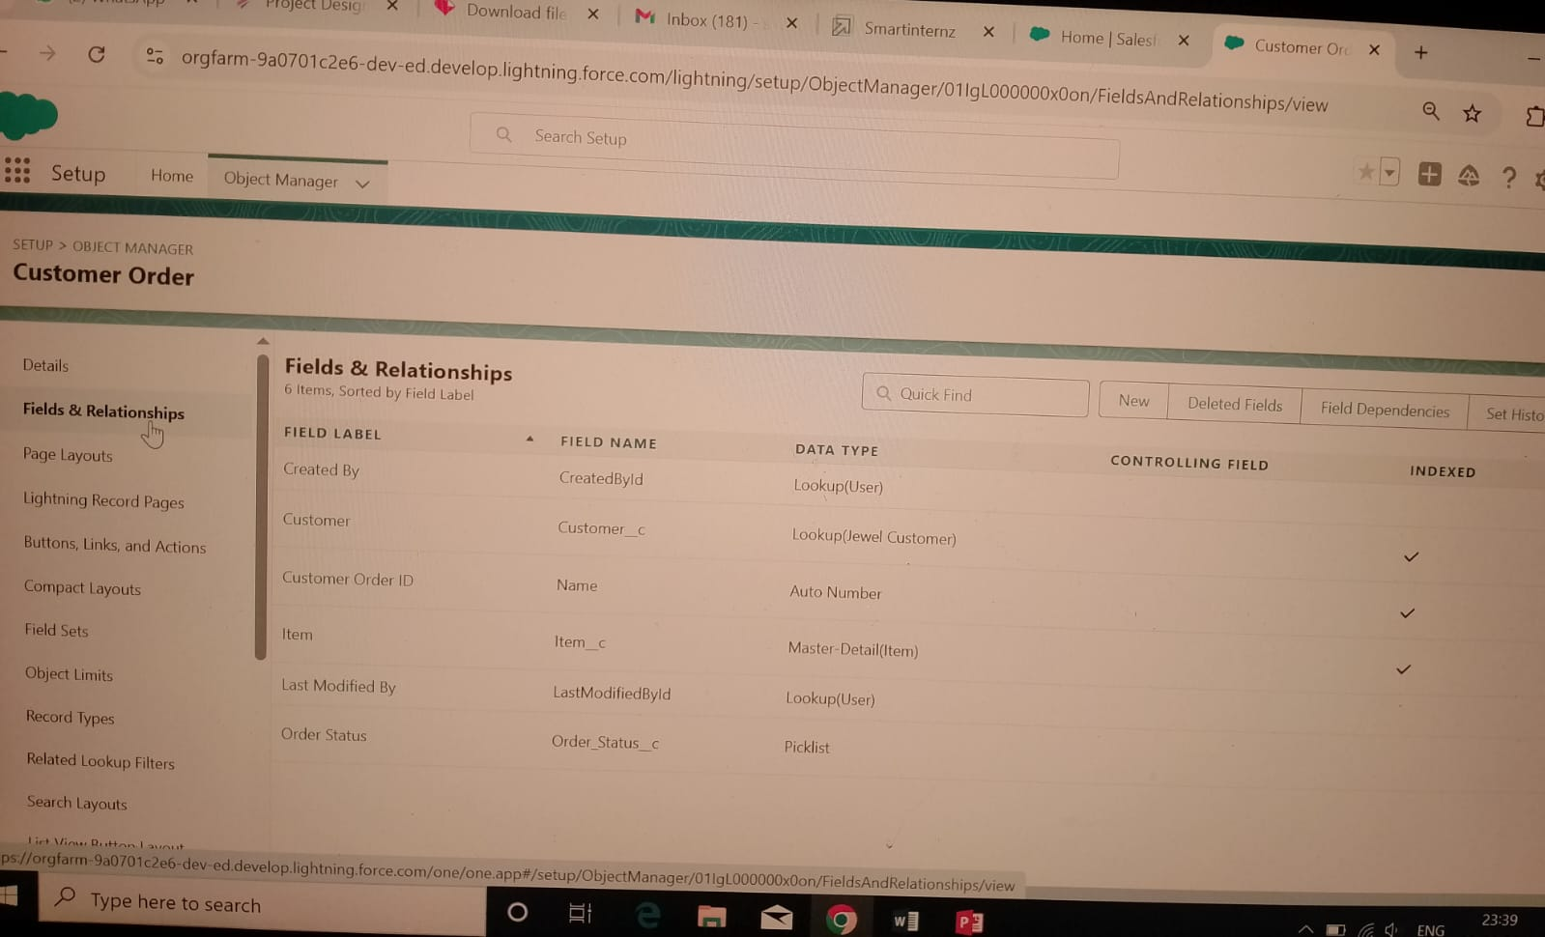

**Creation of Fields in Design request Object:**

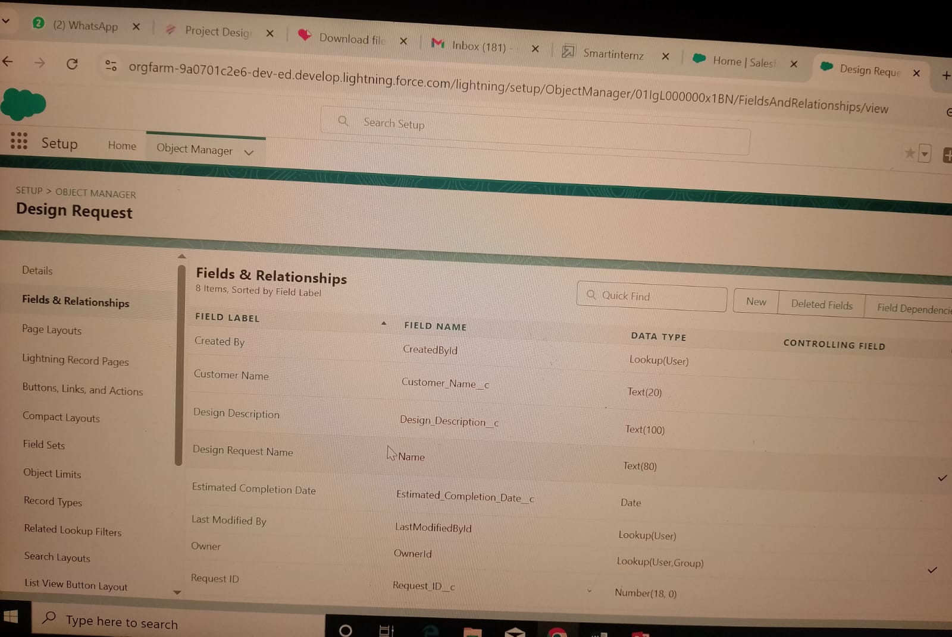

**Creation of Fields in Repair Request Object:**

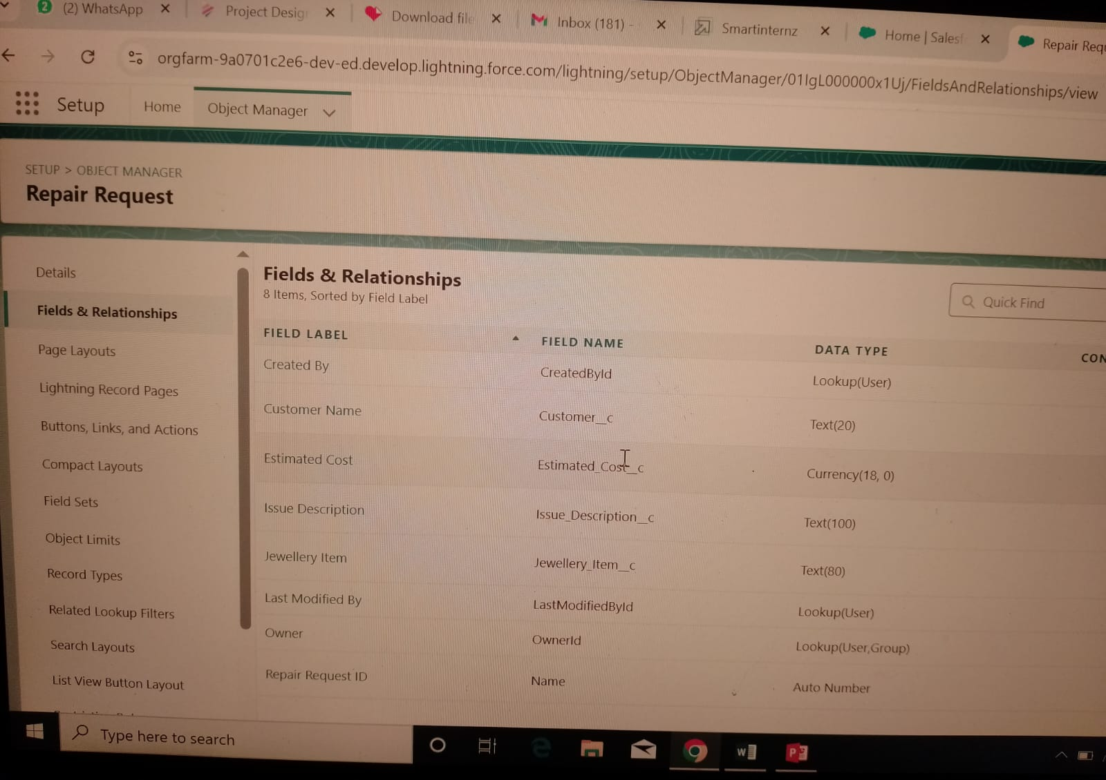

**Creation of Profiles:** Gold Smith and Worker

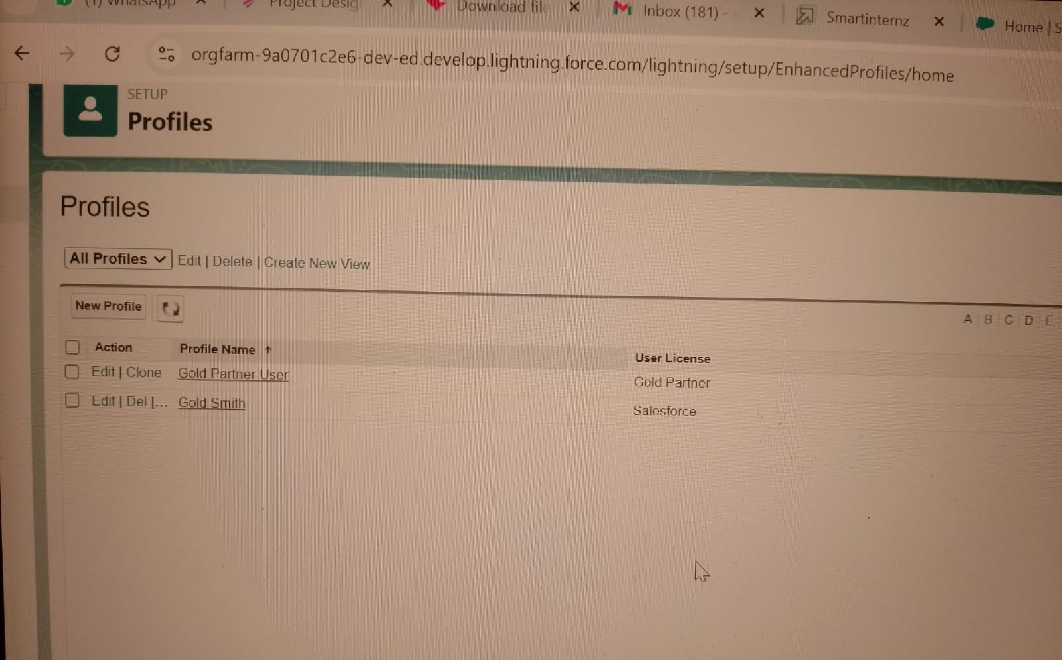

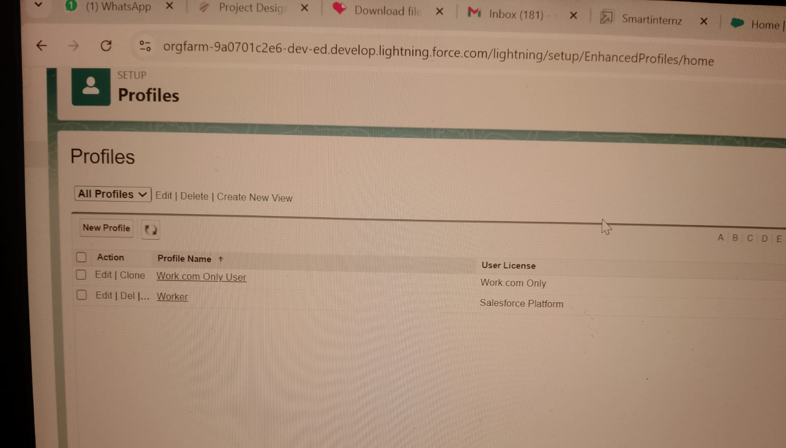

**Creation of Gold Smith Role:**

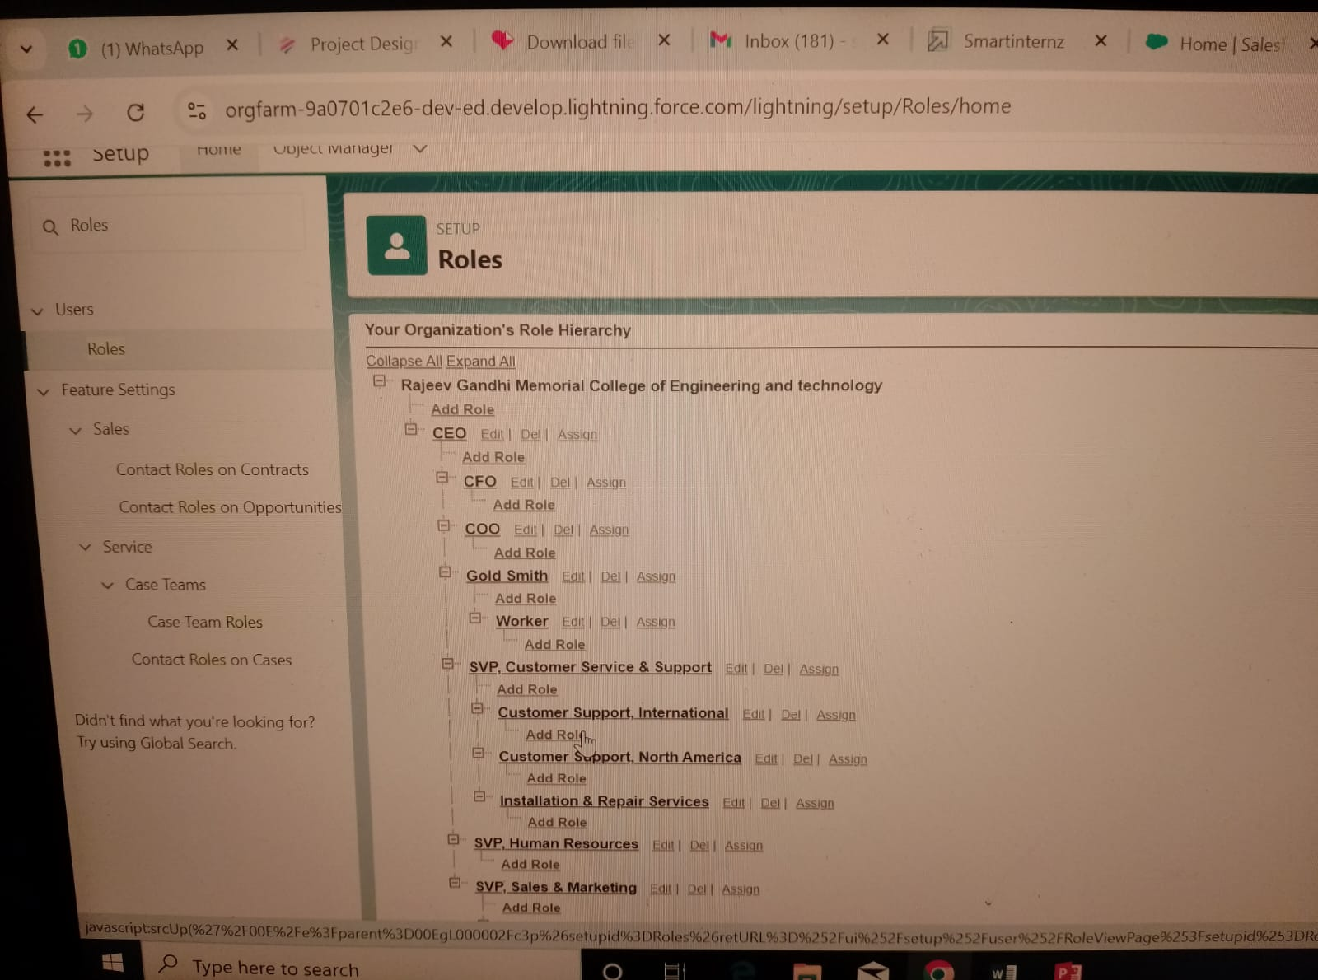

**Creation of users:** Sara Joshi , Akash Mehta, Kol Mikaelson, Nikalus Mikaelson

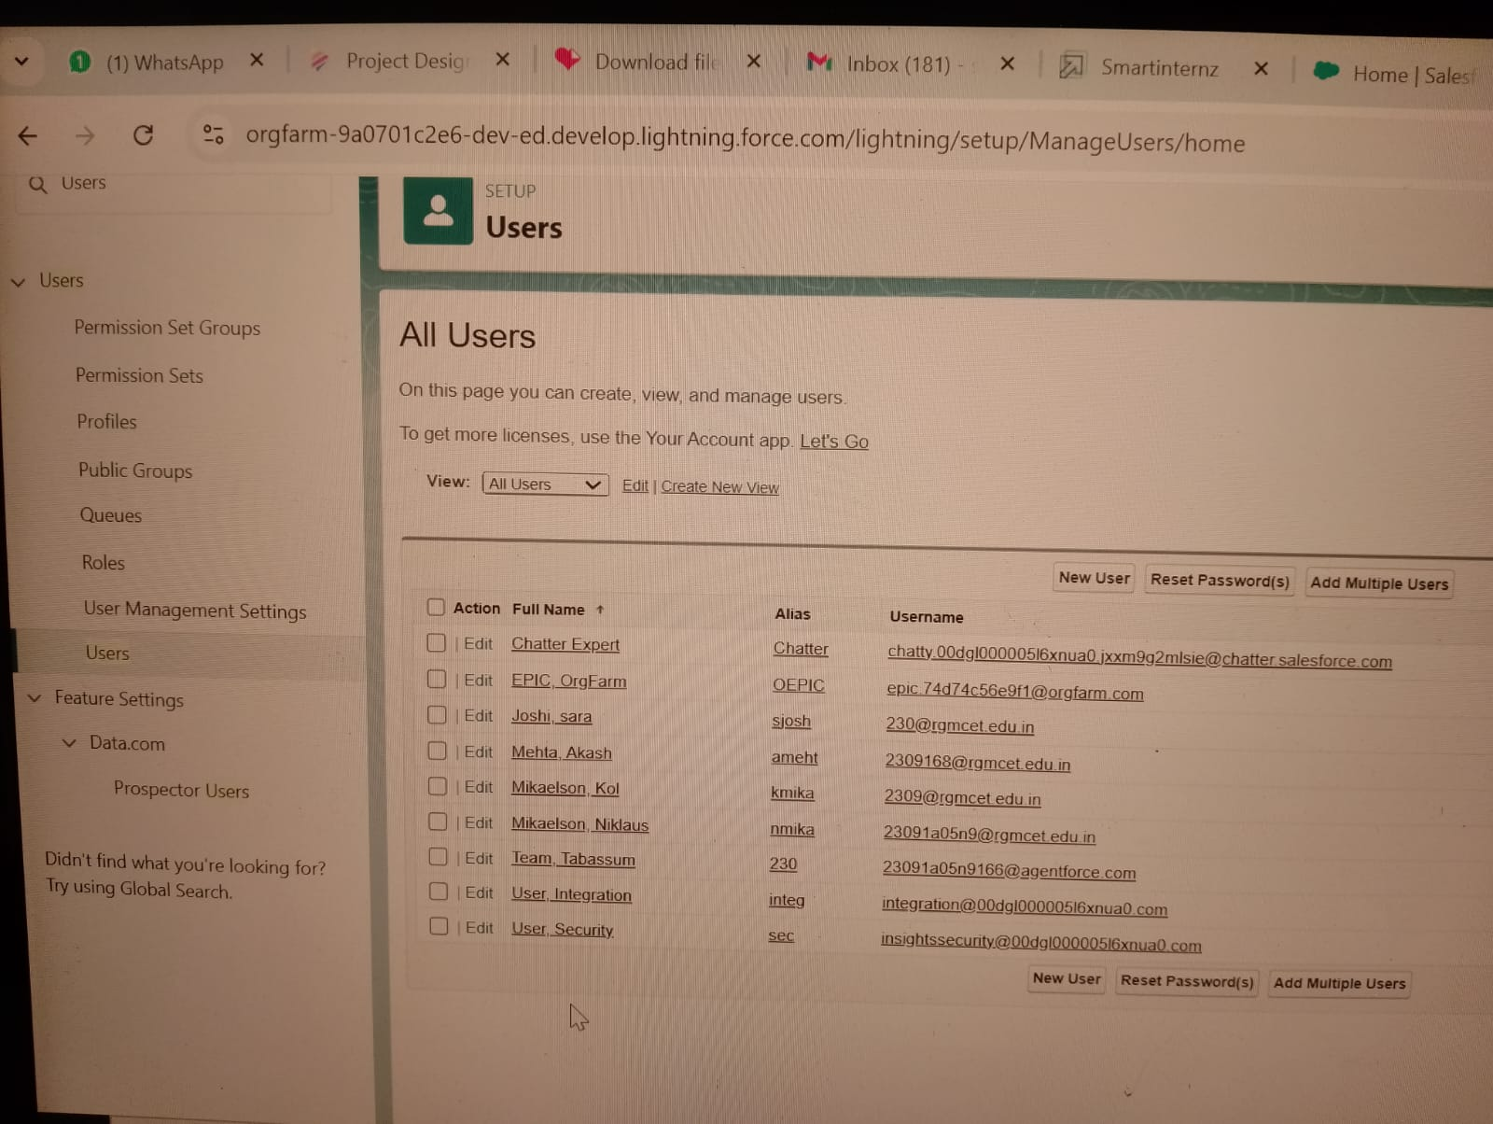

Creation of PageLayouts:

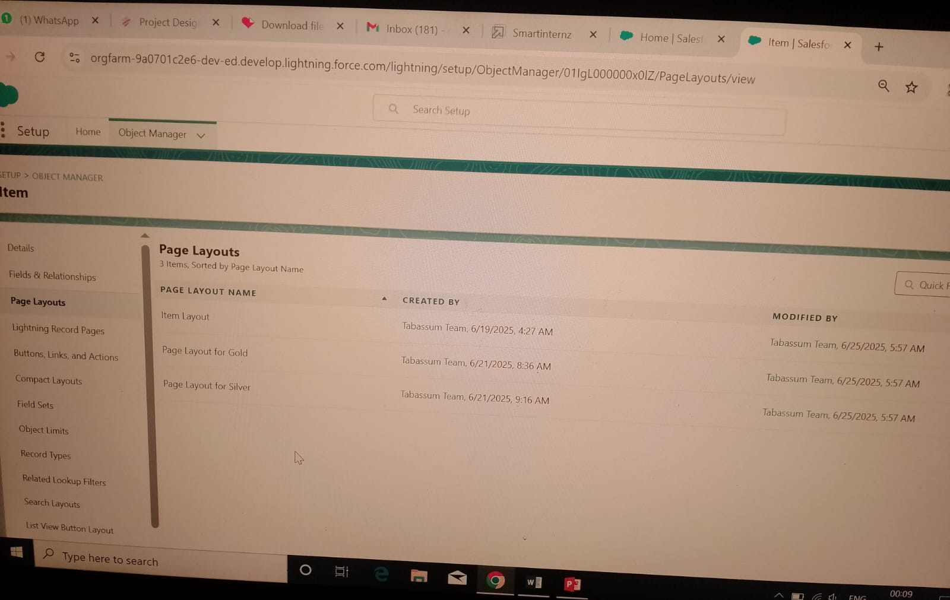

**Creation of Permission Sets:**

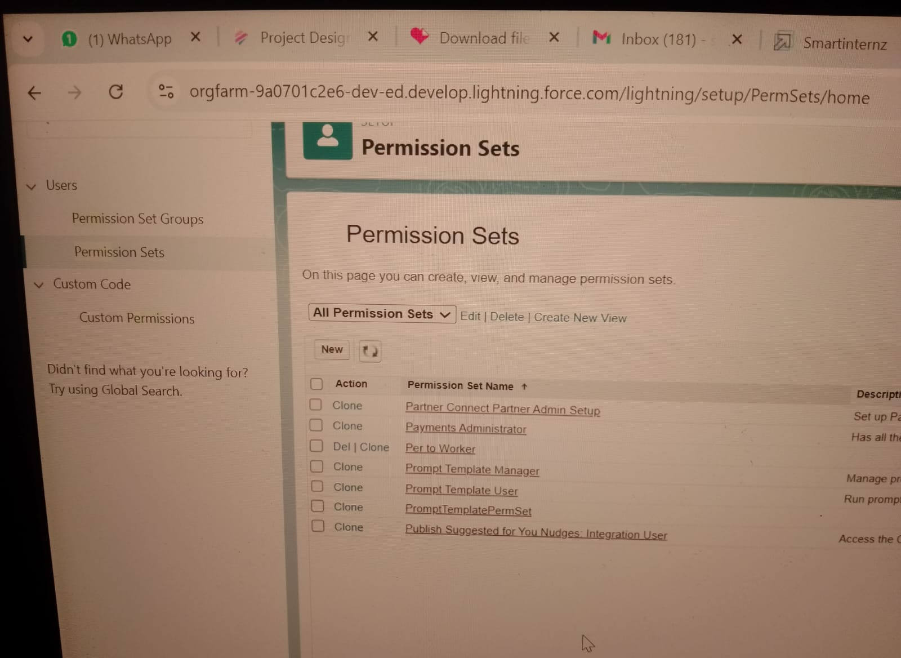

**Creation of Reports:**

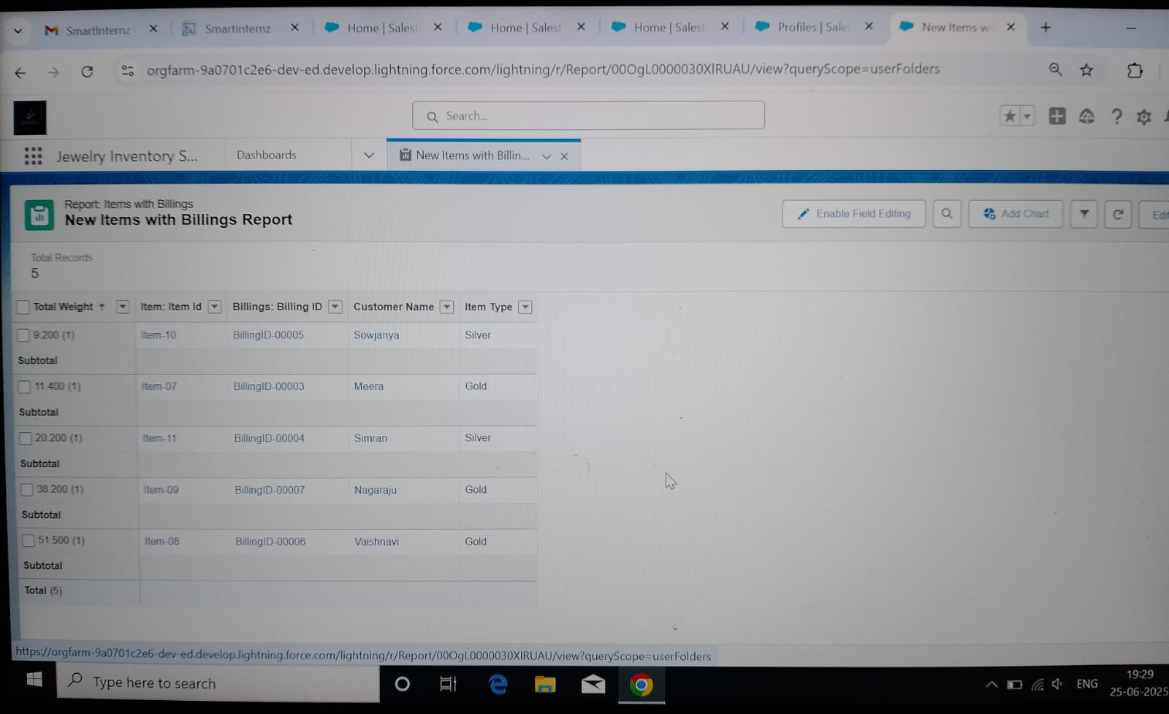

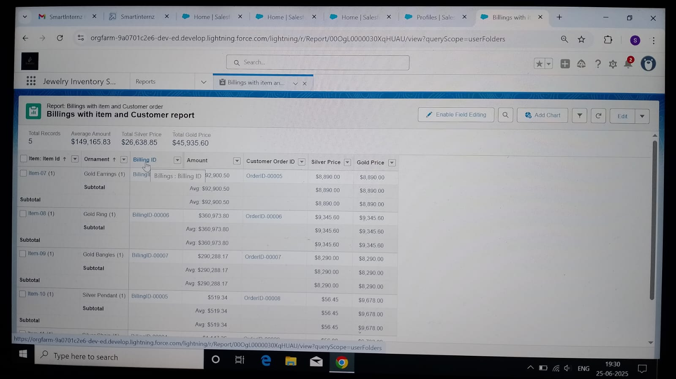

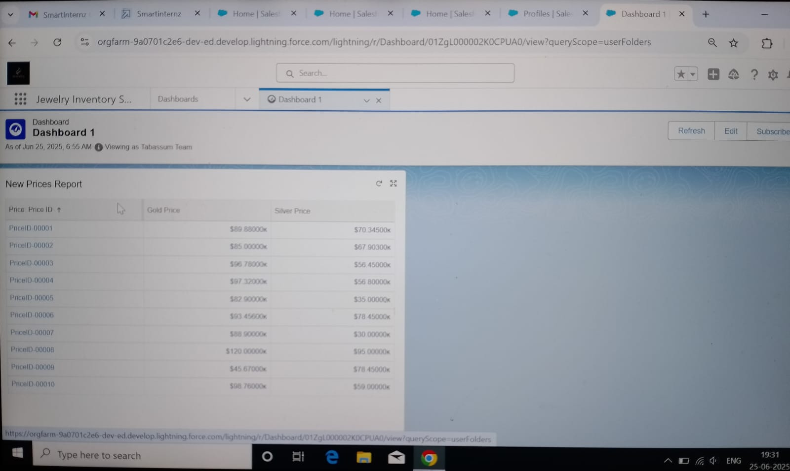

**Creation of Dashboards:**

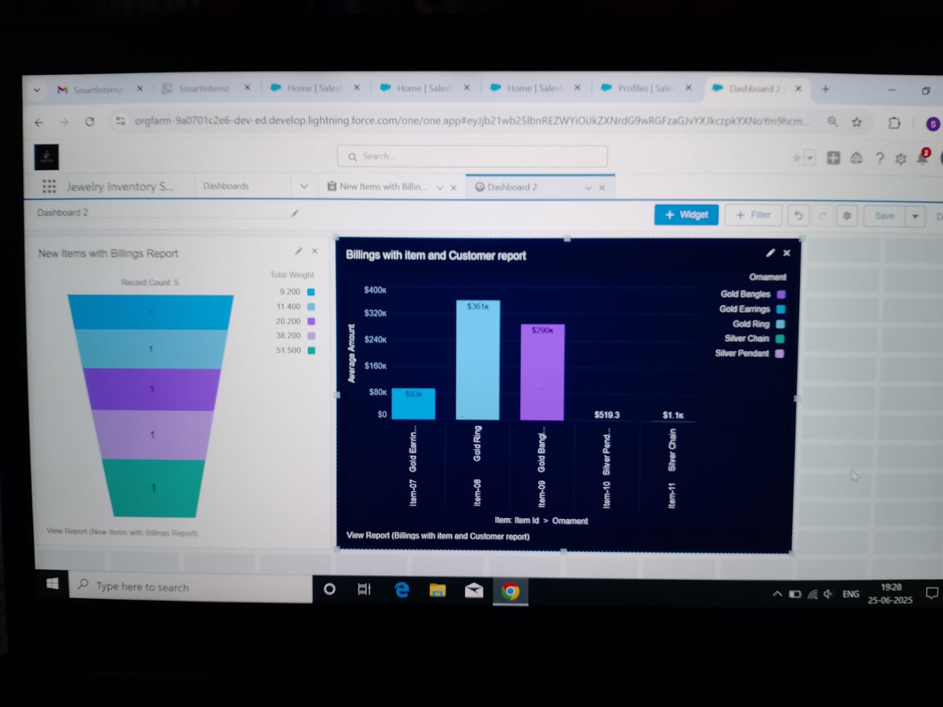

**Creation of Flows:**

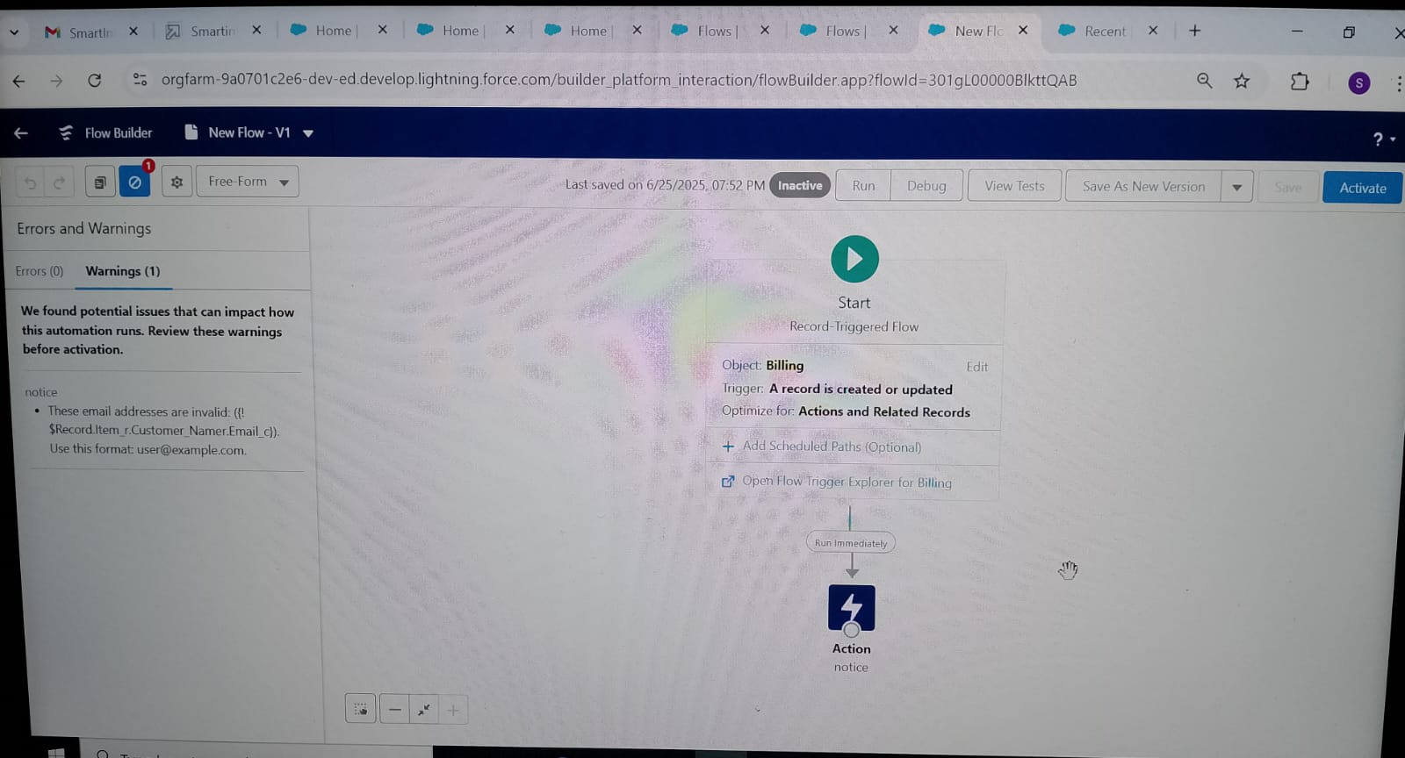

**Creation of Triggers:**



